LAB PROGRAMS 6& 7
NAME:KAVIPRIYA P
REG NO:192424027
LAB PROGRAM :6
!pip install yfinance

import yfinance as yf
import pandas as pd
import matplotlib.pyplot as plt

# Download Alphabet (Google) stock data
df = yf.download('GOOGL',
start='2020-04-01',
end='2020-05-02')

# Scatter Plot
plt.figure(figsize=(8,6))
plt.scatter(df['Volume'], df['Close'])

plt.title('Alphabet Inc. Trading Volume vs Closing Price')
plt.xlabel('Trading Volume')
plt.ylabel('Closing Price (USD)')
plt.grid(True)

plt.show()
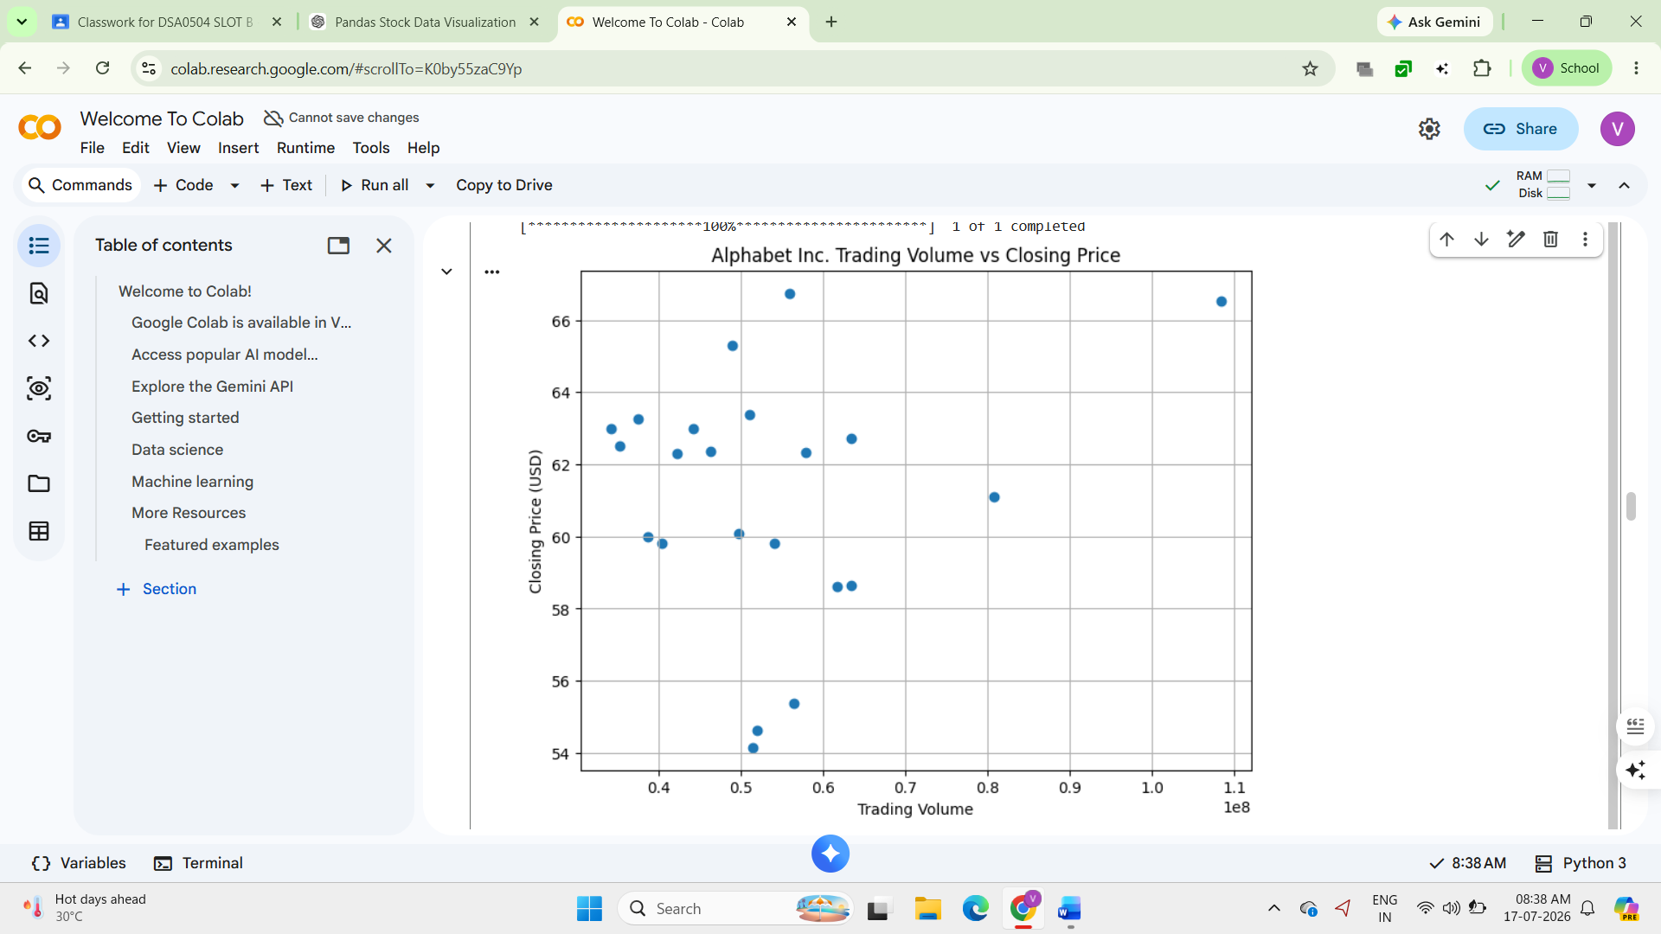

LAB PROGRAM :7
!pip install yfinance

import yfinance as yf
import matplotlib.pyplot as plt

# Download stock data between two dates
stock = yf.download('GOOGL',
start='2023-01-01',
end='2023-06-30')

# Scatter Plot
plt.figure(figsize=(10,6))
plt.scatter(stock['Volume'],
stock['Close'],
alpha=0.7)

plt.title('Scatter Plot of Volume and Stock Price')
plt.xlabel('Trading Volume')
plt.ylabel('Stock Closing Price')
plt.grid(True)

plt.show()
